Getting Started



This document outlines the procedures used in creating the initial build of a project utilizing Visual Studio Community 2019 with GitHub Extension for Visual Studio and GitFlow for Visual Studio 2019.

Table of Contents
Repository Setup 2

Repository Setup

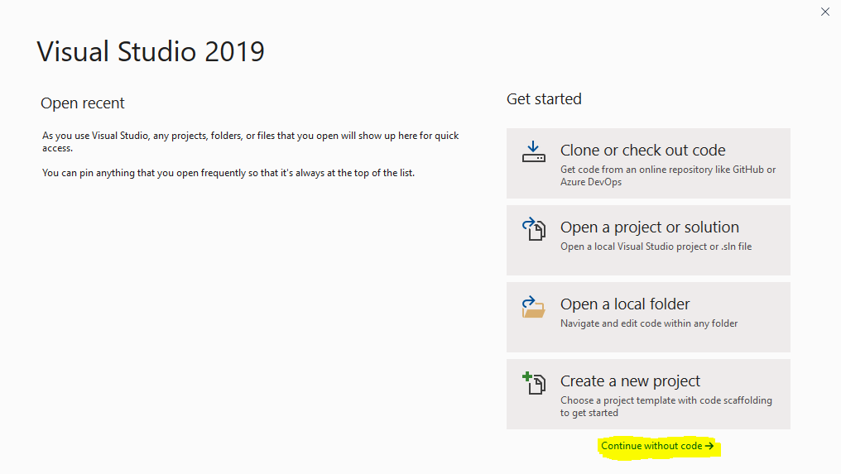
- Open Visual Studio and select the “Continue without code” option located at bottom right of screen.

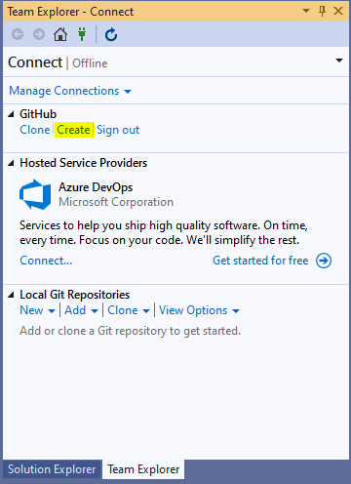
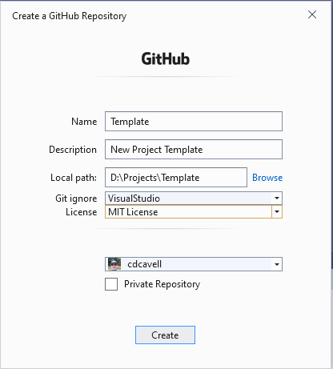
- From Team Explorer Manage Connections, select the Create option under the GitHub section. Enter name, description, location of local repository as well as other information and click Create button.

- Add and modify initial file and folder layout for project and then perform initial commit but do not sync at this point.
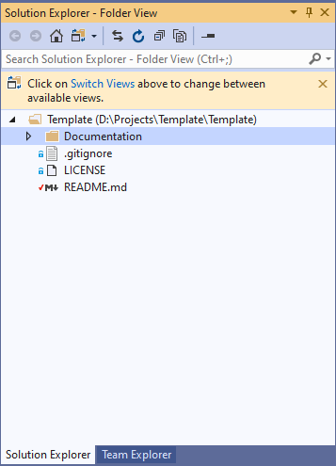
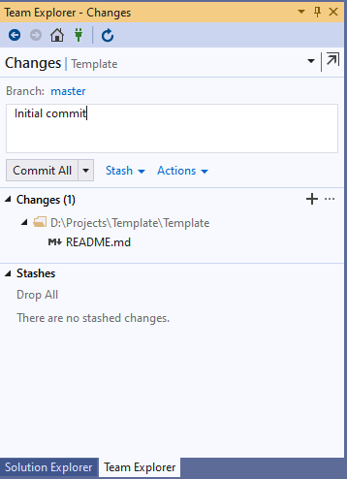
- Choose File/New/Project and select Blank Solution. Place in new repository root and perform another commit.
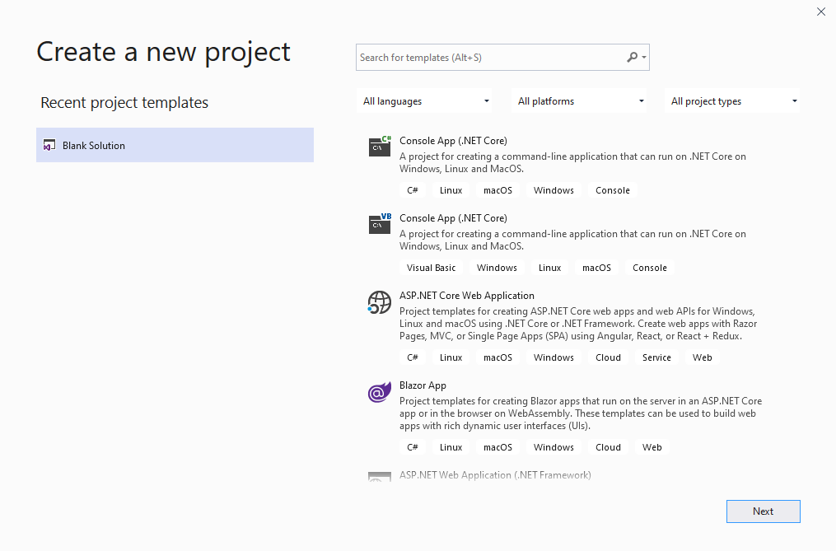
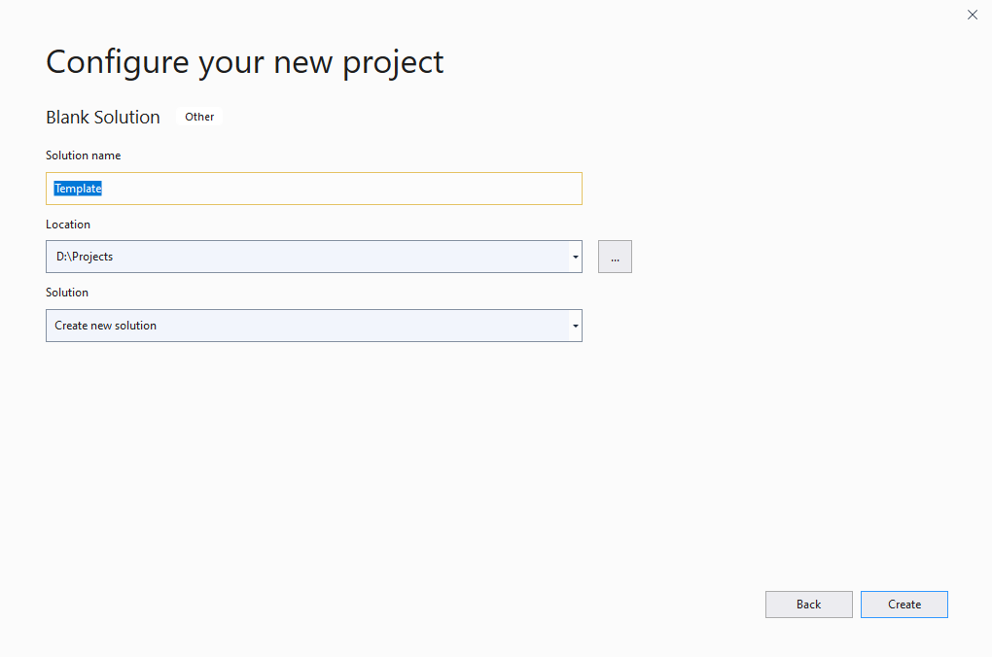

- Go to GitFlow and initialize keeping default settings. Afterwards, sync both master and develop branches. You can then set repository configurations in GitHub web application for your new repository.
